**Assignment No:-73**

Name:-Suryawanshi Sangramsingh Sambhaji

Batch: - Delta - DCA (Java) 2024 Date:-9/9/2024

**Create a Database and Collection:**

Write a MongoDB query to create a database called EmployeeDB and a collection called employees.

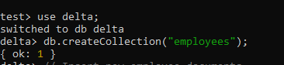

**Insert Multiple Documents:**

Insert multiple employee documents into the employees collection. Each document should contain fields like name, age, position, department, and salary.

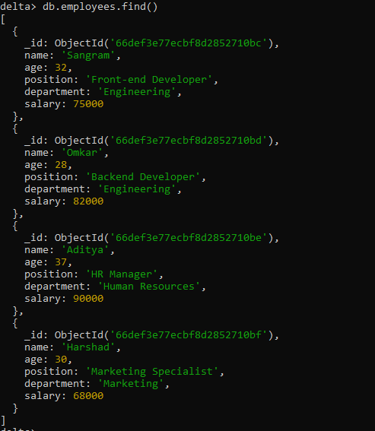

**Find Documents with a Condition:**

Write a query to find all employees in the employees collection where the age is greater than 30.

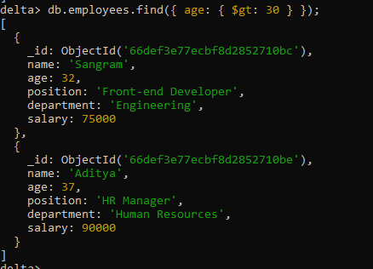

**Update Documents:**

Update the salary of an employee whose name is "John Doe" by increasing it by 5000.

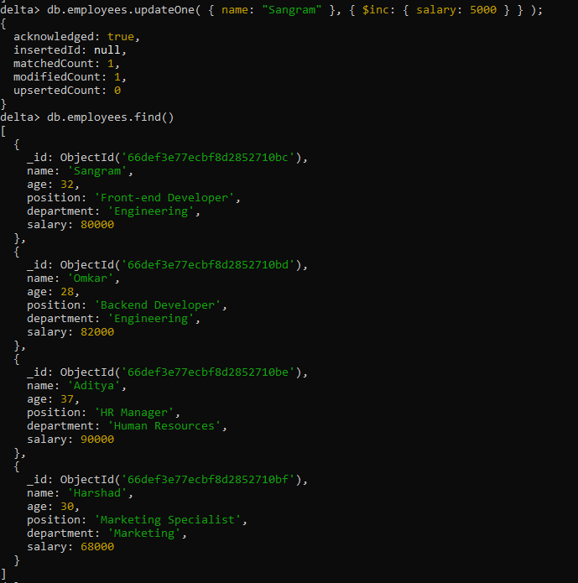

**Delete a Document:**

Delete the document of an employee whose name is "Sangram".

Sort Documents:

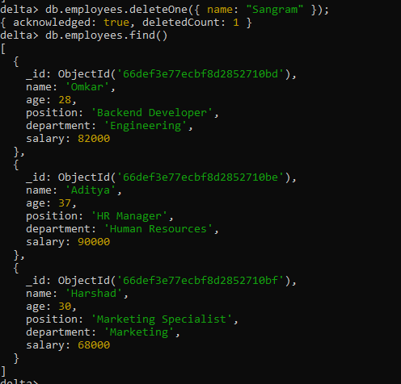

Write a query to sort all the employees based on salary in descending order.

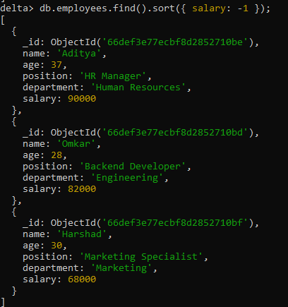

**Aggregate Data:**

Use the aggregation framework to find the average salary of employees grouped by the department field.

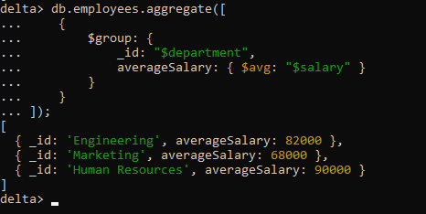

**Find Specific Fields:**

Write a query to find all employees but only return their name and position fields.

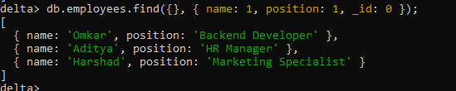

**Add a Field to Documents:**

Update all documents in the employees collection by adding a new field called isActive with a value of true.

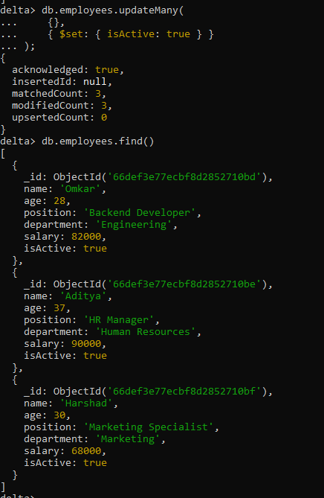

**Using $or Operator:**

Write a query to find all employees who either belong to the "Sales" department or have a salary greater than 70000.

